Shoby Keneth R. Daamo
BSIT – 3A
TECH. COMPONENTS
SUBTOPIC 1: Computer Components
ID | NAME | DESCRIPTION | PRICE | PICTURE
1 | CPU / Processor | Central processing unit that executes computer instructions. | ₱5,000–10,000 | 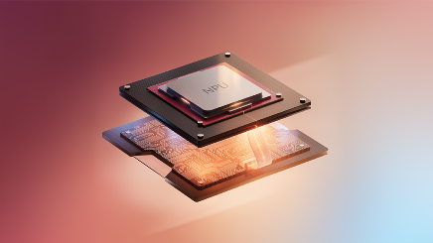
2 | Motherboard | Main circuit board that connects computer components. | ₱5,000–7,000 | 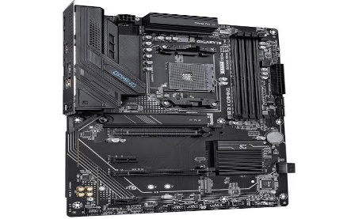
3 | RAM | Temporary memory used by the computer to run programs. | ₱4,500–6,000 | 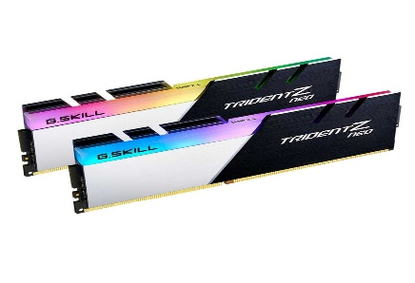
4 | GPU | Processes graphics and visual information for display. | ₱10,000–50,000 | 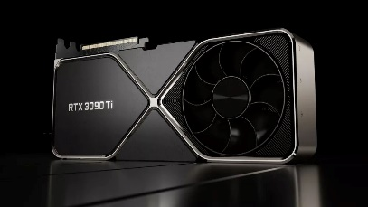
5 | PSU | Supplies electrical power to computer components. | ₱5,000 | 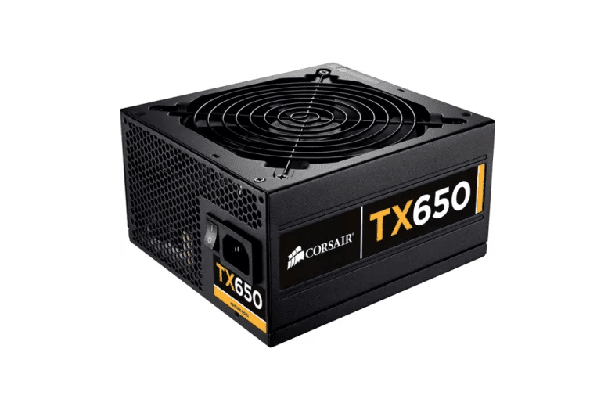

SUBTOPIC 2: Storage Devices
ID | NAME | DESCRIPTION | PRICE | PICTURE
1 | HDD | Magnetic storage device used to save files and data. | ₱2,500–5,000 | 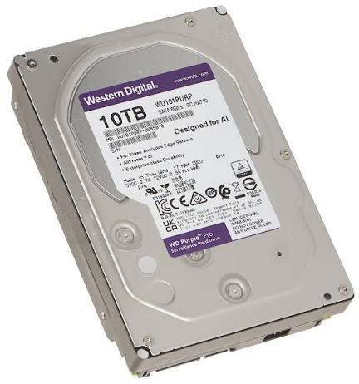
2 | SSD | Fast storage device that uses flash memory. | ₱5,500–10,000 | 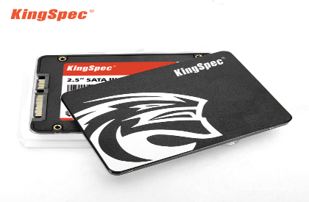
3 | NVMe SSD | High-speed solid-state storage using the NVMe protocol. | ₱6,000–15,000 | 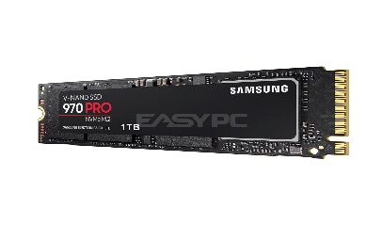
4 | USB Flash Drive | Portable device used to store and transfer digital files. | ₱1,500–2,000 | 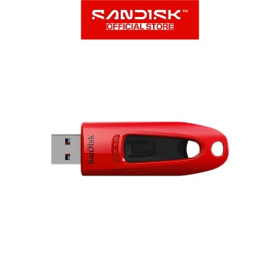
5 | Memory Card | Small storage device used in phones, cameras, and other devices. | ₱800–1,500 | 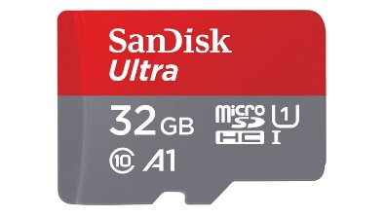

SUBTOPIC 3: Computer Accessories
ID | NAME | DESCRIPTION | PRICE | PICTURE
1 | Keyboard | Input device used for typing and controlling a computer. | ₱500–2,000 | 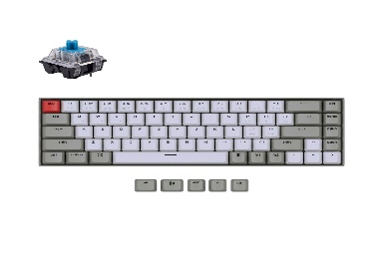
2 | Mouse | Pointing device used to navigate and interact with a computer. | ₱300–1,500 | 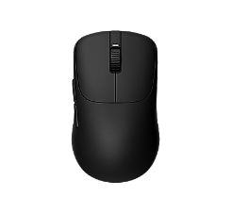
3 | Webcam | Camera used for video calls, meetings, and streaming. | ₱800–3,000 | 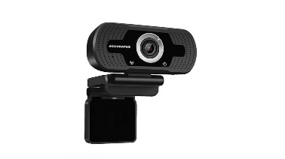
4 | Speakers | Audio output device used to play sound from a computer. | ₱500–3,000 | 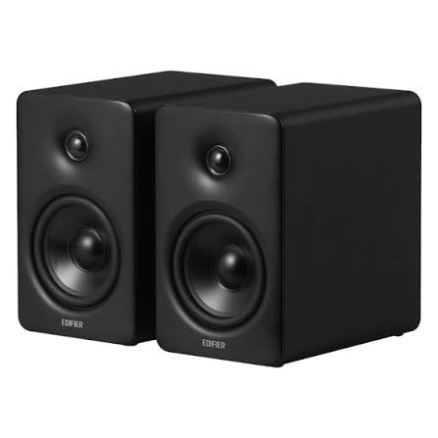
5 | Headset | Audio device with headphones and a microphone. | ₱500–2,500 | 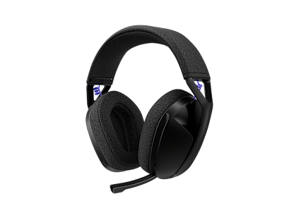

SUBTOPIC 4: Networking Components
ID | NAME | DESCRIPTION | PRICE | PICTURE
1 | Wi-Fi Router | Network device that provides wireless connectivity. | ₱1,000–5,000 | 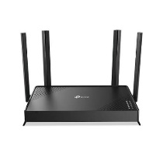
2 | Network Switch | Connects multiple devices within a local area network. | ₱500–3,000 | 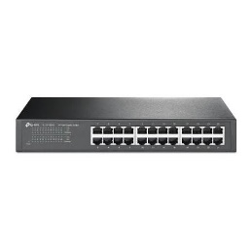
3 | Ethernet Cable | Connects network devices through wired communication. | ₱100–500 | 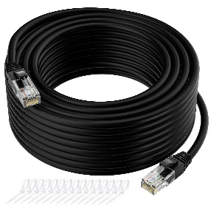
4 | Wi-Fi Adapter | Allows a computer to connect to a wireless network. | ₱300–1,500 | 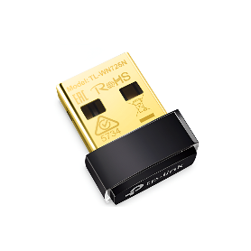
5 | LAN Card | Network interface device for wired connectivity. | ₱300–1,500 | 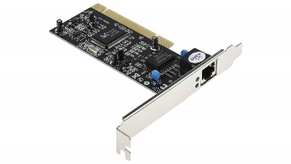

SUBTOPIC 5: Power & Connection
ID | NAME | DESCRIPTION | PRICE | PICTURE
1 | HDMI Cable | Transmits digital audio and video between devices. | ₱150–800 | 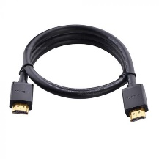
2 | USB Cable | Used for data transfer and charging electronic devices. | ₱100–500 | 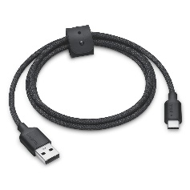
3 | Power Cable | Supplies electrical power to computers and electronic devices. | ₱150–500 | 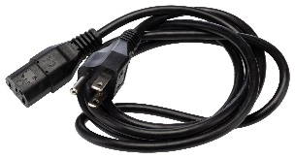
4 | USB Hub | Expands the number of available USB ports. | ₱300–1,500 | 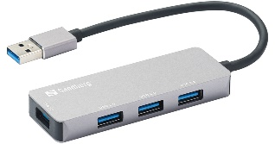
5 | Surge Protector | Helps protect electronic equipment from voltage surges. | ₱500–2,000 | s